**Machine Learning Algorithm**

1. Supervised learning

More commonly .

Input to output **Labled.**

„learn from being given „right answers” “.

Data has “right” answers.

1. Regression (predict a number)
   1. Predicts a number  
      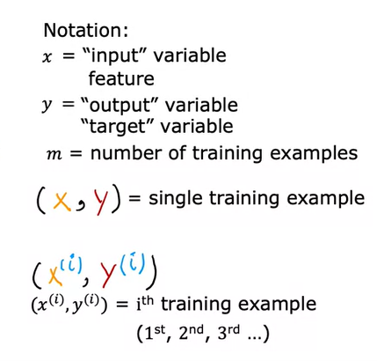 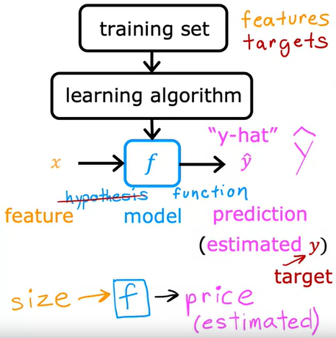

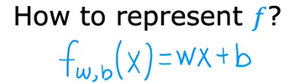

f is a linear function – means only has one variable (**univariate linear regression**)

**w = slope**

**b = interecept**

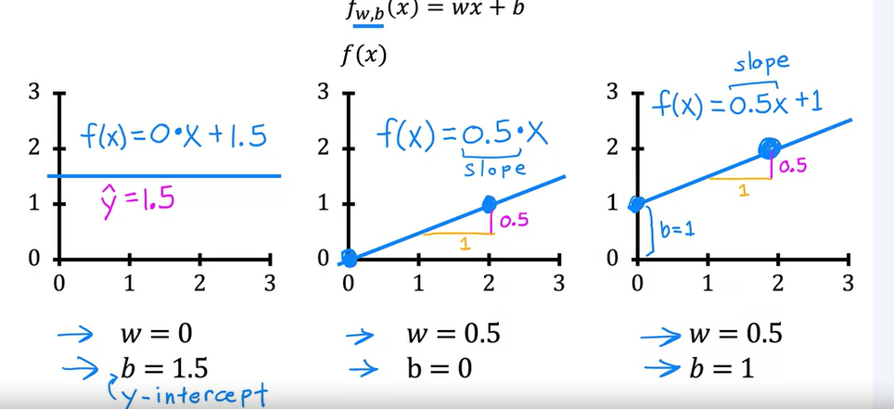

**Cost function**

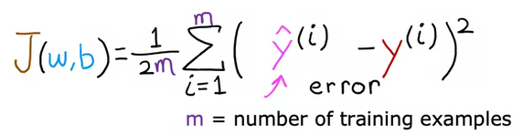

**Goal:** minimize J(w,b) to find the best fitting f(x)

**Gradient Descent**

Find the local minima for the cost function J to minimize it.

Like walking a hill to the valley

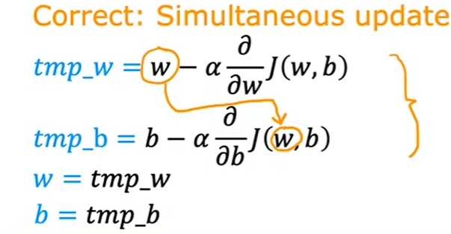

1. Classification
   1. predicts categories
2. Unsupervised learning

**No labels**

Find pattern / interesting informations in unlabeled data